North Lincolnshire Council
Daily Event Analysis
7th December 2010

Overview
On Tuesday 7th December ten of the eleven PM₁₀ air quality sites monitored by North Lincolnshire Council measured a mean PM₁₀ concentration above the 50μg/m³ allowed as a daily mean. These sites are plotted on the graph below. The highest mean PM₁₀ concentration was recorded at the Low Santon TEOM measuring 107μg/m³. Many of the sites are located outside the Scunthorpe Town area and are not normally considered as being affected by the integrated works. Higher mean PM₁₀ concentrations were however measured at local sites upwind of the integrated steel works site.
Site | Mean PM₁₀ Concentration (7.12.10)
Amvale | 77μg/m³
Appleby | 82μg/m³
East Common Lane | 55μg/m³
Killingholme | 64μg/m³
Lincoln Gardens | 52μg/m³
North Lincs Santon Dawes Lane | 100μg/m³
Redbourn Club | 53μg/m³
Santon TEOM | 107μg/m³
Scunthorpe Town | 59μg/m³
South Ferriby | 59μg/m³

Met Conditions
The wind throughout the day ranged between 128° and 341°. Wind speeds averaged at 1 m/s with much of the day remaining still. Snow covered the ground in all areas except for roads which were mostly clear.

Exceedance Sites
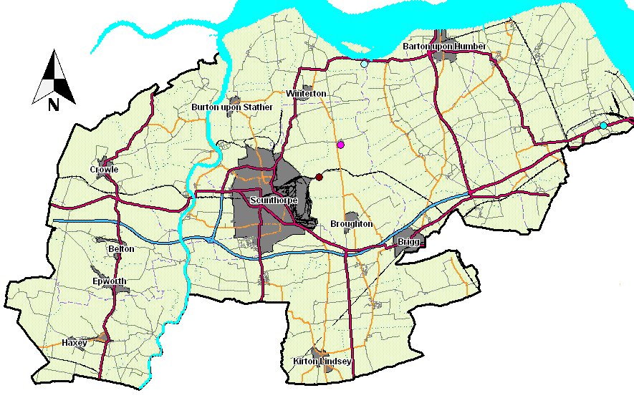
Map 1

Map 2

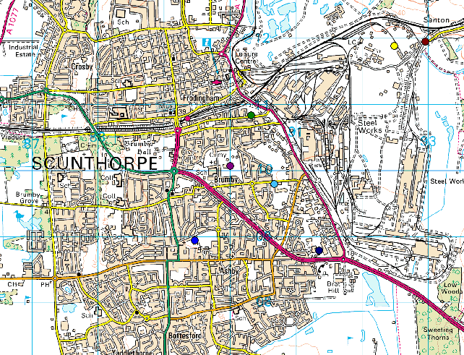

Maps 1 and 2 show the location of the 10 air quality monitoring sites that exceeded the 50μg/m³ limit on Tuesday 7th December. It is difficult to attribute the exceedances to a specific source due to the number of locations and the large wind range for the day. However it was noted that sites downwind of the steel works experienced lower mean concentrations than those upwind. At East Common Lane a mean concentration of 55μg/m³ was recorded and at the Lincoln Gardens site 52μg/m³. The Santon TEOM recorded a mean concentration of 107μg/m³. The highest PM₁₀ concentration measured at the Santon TEOM was 237μg/m³ indicating a potential gain across the integrated steel works site of 180μg/m³ from Lincoln Gardens.

Santon Analysis
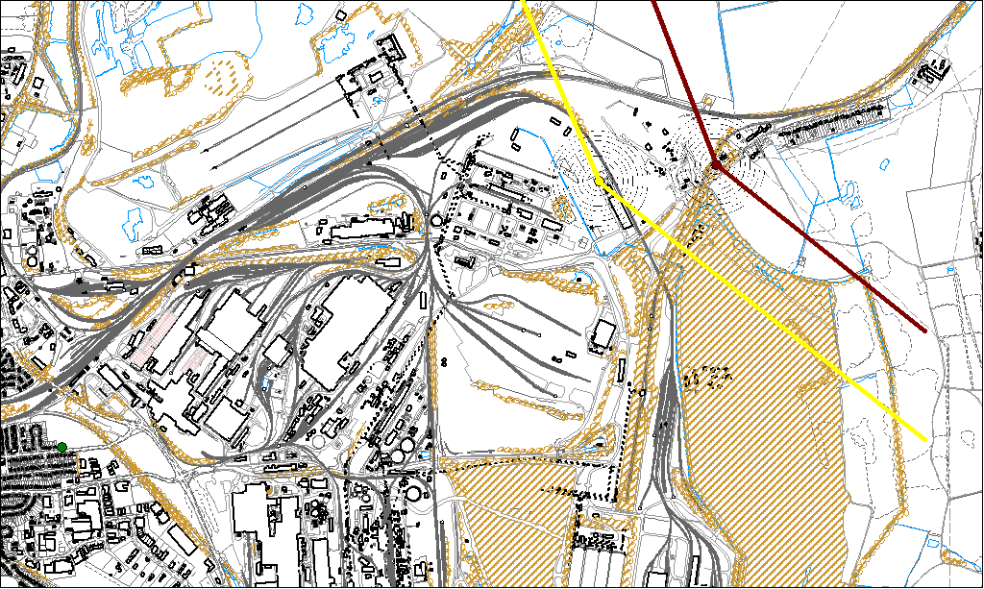

Both the Santon TEOM and the Dawes Lane Osiris were over the 50μg/m³ limit throughout the day therefore the wind range for the whole day is represented on the map above. The mean at the Santon TEOM was 107μg/m³ and 100μg/m³ at the Dawes Lane Osiris. The Santon TEOM peaked at 237μg/m³ and the Dawes Lane Osiris at 233μg/m³.

Information from TATA and Tarmac indicate that much of the ground and stockpiles on the integrated site were covered in snow and there was very little movement. This indicates that it is unlikely fugitive emissions were responsible for the exceedances.

It was observed that emissions from the stacks on the integrated works were not dispersing as efficiently under the met conditions being experienced. It is possible therefore that the stacks are a potential source contributing to the exceedances on the steel works site. Localised traffic may have also played a large part in the county wide event. Poor dispersion from traffic emissions may account for the higher concentrations due to the slow moving traffic and idling cars.

A review of the AURN network sites showed similar concentrations indicating a number of localised events on a national scale. North Lincolnshire sites downwind of the integrated works appear to have recorded higher concentrations because of the poor dispersion from site stacks combined with effects of localised traffic. Sites upwind appear to have recorded higher than normal numbers because of this localised traffic. Combine this with increased domestic fuel use and higher levels nationally North Lincolnshire Council recorded an exceedance at almost every monitoring station.

